As a Doctor, I would like to be able to edit other fields within the edit doctor page (conditions, specialty, license, insurance, etc)

**Introduction**

The RevDoc application is to provide the doctors the ability to edit other fields within the edit doctor page (conditions, specialty, license, insurance, etc) .

**Diagram of database tables**

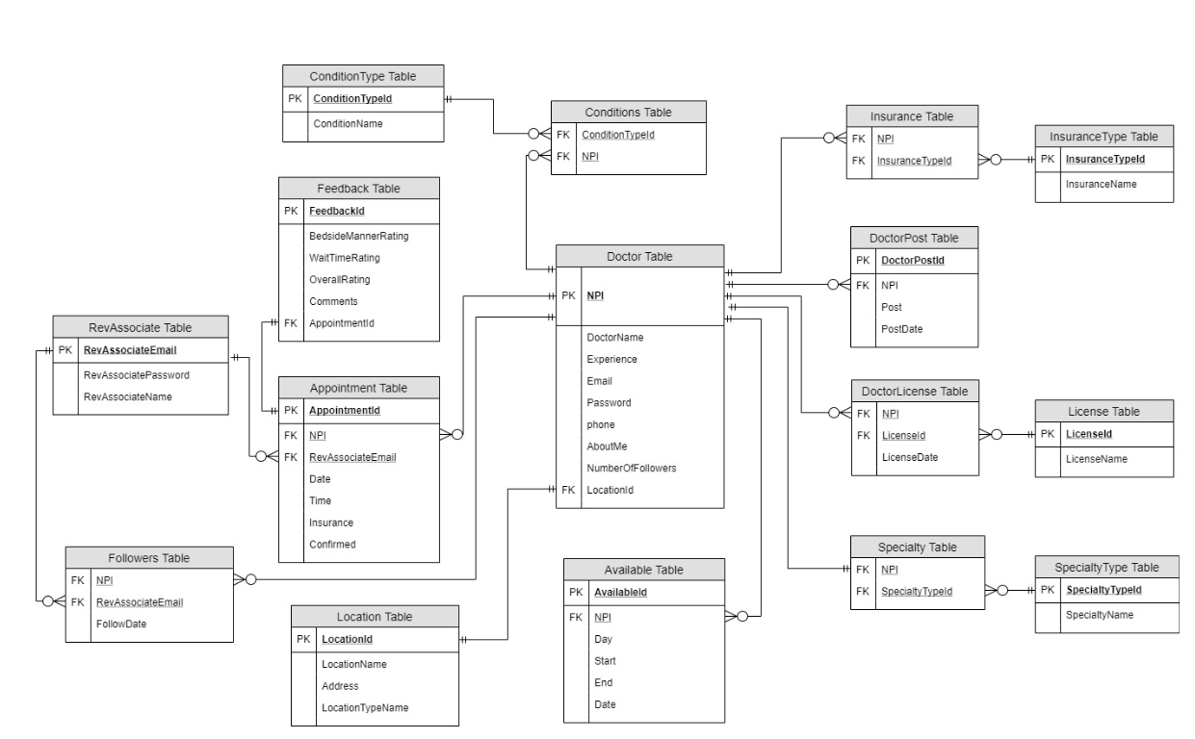

According to the figure above, the RevDoc application will populate all the essential fields in tables Conditions, ConditionType, Insurance, InsturanceType, Specialty, SpecialtyType, License, and Doctor_License on UI page for doctors to edit.

Design Overview

The RevDoc applicaion retrieves doctor profile by npi from database and send back to the client side or UI page. Doctors make changes in the edit doctor profile page. When submit, the data will send back to the server side for update. After receiving the Http request, information will be mapped into appropriate tables and fields to be updated in the database.

Detail Design

Retrieve Doctor’s Data by Npi and Send to the Client Side

Controller Layer

Upon receive the Http request with appropriate mapping, the request will be routed to the service layer with the uri which identifies the doctor profile index for data lookup. When getting the information, it will be sent back to the client side to be displayed on the UI page.

Service Layer

The request will be sent to DAO layer, expecting for the return of object array where each object can be doctor’s name, doctor’s experience, doctor’s phone, doctor’s license id, doctor’s insrance name, etc.

DAO Layer

The optional query is performed, to select all fields in the tables (Conditions, ConditionType, Insurance, InsturanceType, Specialty, SpecialtyType, License, and Doctor_License) with SQL join statement which matches the given Npi.

Update Doctor’s Data After Receiving From the Client Side

Controller Layer

Upon receive the Http request with Http Request body, this array of object will be transferred to the service layer to be prepared for the update.

Service Layer

The incoming array of objects will be mapped into the appropriate table and fields. Then it calls the JPA repository’s call method for updating the data.

DAO Layer

The update will be performed automatically for all tables.